**DEPARTMENT OF COMPUTER SCIENCE & ENGINEERING**

MINI PROJECT / INTERNSHIP (BCC-351)



#### SESSION- 2024-25

Submitted by**: -** Submitted to: -

#### **JYOTIRADITYA UPADHYAY**(2312160100036) Mr. ASIT SINGH

#### KARTIKEY PANDEY(2312160100037) (Computer Science & Engg.)

#### **KHUSHI TRIPATHI**(2312160100038)

#### 

Year-2rd

Branch: - COMPUTER SCIENCE & ENGINEERING

**RAJKIYA ENGINEERING COLLEGE**

**PRATAPGARH**

**(An Autonomous Govt. Engg. Institute under 2f and 12B UGC Act)**

**Affiliated to**

**Dr. A. P. J. ABDUL KALAM TECHNICAL UNIVERSITY**

**LUCKNOW (U.P.), INDIA**

**PROJECT REPORT ON**

WonderLust

Vacation Rental Platform

(Web Application)

### DECLARATION

We hereby declare that the work contained in the project titled "WonderLust- Vacation Rental Platform WebApp Using MERN Stack" is my original work. We have not plagiarized any other sources and have conducted all research and development independently. We have adhered to the highest standards of academic and professional integrity throughout the project's development.

We have acknowledged all sources of knowledge that I have used in the project, including:

* MERN Stack documentation
* Material UI documentation
* Redux documentation
* Relevant online tutorials and resources
* My own knowledge and understanding of web development and functionality

We have not engaged in any unethical practices during the project, such as:

* Copying code or content from other sources without proper citation
* Collaborating with others on the project without explicit permission from relevant contributors
* Misrepresenting the origin of any work or ideas

We understand that plagiarism and other forms of academic and professional dishonesty are serious offenses that can result in severe consequences, including damage to reputation and legal actions. We are committed to upholding the highest standards of integrity and have taken all necessary steps to ensure that my work is original, ethical, and complies with legal and professional standards.

We have read and understood the project ethics guidelines and have followed them to the best of my abilities. We are confident that our work is original, and we have met all the requirements of the project.

## Jyotiraditya Upadhyay Kartikey Pandey Khushi Tripathi

## (2312160100036) (2312160200037) (2312160100038)

### CERTIFICATE

This is to certify that Jyotiraditya Upadhyay (2312160100037), Kartikey Pandey (2312160100037) & Khushi Tripathi (2312160100038) has successfully completed the mini project on "WonderLust- Vacation Rental Platform WebApp Using MERN Stack" under the guidance of Mr. Asit Singh. The contents of the project, being submitted to the Department of Computer Science and Engineering, REC Pratapgarh, for the award of the degree of B. Tech in Computer Science & Engineering, are original and carried out by the candidates. This project has not been submitted in full or part for the award of any other degree or diploma to this or any other university.

**Mr. Asit Singh**

# ACKNOWLEDGEMENT

It gives us a great sense of pleasure to present the report of the B. Tech Mini Project undertaken

during B. Tech. Second Year. We owe special debt of gratitude to Mr. Asit Singh, Department of Computer Science & Engineering, REC Pratapgarh for his constant support and guidance throughout the course of our work. His sincerity, thoroughness and perseverance have been constant source of inspiration for us. It is only his cognizant efforts that our endeavors have seen light of the day.

We also take the opportunity to acknowledge the contribution for his full support and

assistance during the development of the project. We also would not like to miss the opportunity to acknowledge the contribution of all faculty members of the department for their kind assistance and cooperation during the development of our project. Last but not the least, we acknowledge our parents and friends for their constant support throughout the project.

## Jyotiraditya Upadhyay Kartikey Pandey Khushi Tripathi

## (2312160100036) (2312160200037) (2312160100038)

# ABSTRACT

The mini project/internship centres on the development of an Vacation Rental Platform named

'WonderLust,'. In an age where access to diverse product offerings are paramount, 'WonderLust' aims to provide a feature-rich platform with an intuitive user interface.

#### Key features of the E-commerce Website include:

* **User Authentication**: 'WonderLust' incorporates a secure login and logout system, ensuring user data privacy and authentication.
* **Places Listing**: The webapp showcases an extensive array of places, with the capability to view details and add or remove places from the listing.
* **MERN Stack Implementation**: The full-stack development using MERN (MongoDB, Express.js, React, Node.js) ensures robust and scalable performance.
* **API Integration**: 'WonderLust' leverages APIs to facilitate seamless communication between the front end and back end, enhancing the overall functionality of the

website.

* **Material-UI and Redux**: The incorporation of Material-UI ensures a modern and

visually appealing design, while Redux manages state efficiently, providing a smooth and responsive user experience.

This WebApp adheres to contemporary design principles, ensuring a user- friendly interface for optimal accessibility. The project not only showcases the practical application of advanced programming skills but also underscores the importance of delivering a reliable and streamlined platform for users engaging in online places listing activities in today's dynamic digital landscape.

# INDEX

1. Introduction… 2-6
   1. Project Objectives… 3
   2. Justification and Need… 4
   3. History… 5
2. Requirement Analysis 6-14
   1. Analysis Study… 8
   2. User Requirements… 9
   3. Final Requirements… 10
   4. Flowchart… 11-12
   5. Entity Relationship Diagram… 13-14
3. Implementation… 15-25
   1. Languages/Technologies used… 15-19
   2. Proposed Method 20-24
   3. Summary… 25
4. Conclusion and Future Scope 26-28
   1. Result and Conclusion… 26
   2. Future Scope 27
5. Reference 28
6. Appendix… 28

# INTRODUCTION

In an era where digital commerce has revolutionized the way we shop and transact, the demand for an efficient and user-friendly e-commerce platform is more critical than ever. This Mini Project revolves around the creation of 'Umakechoice,' an innovative E-commerce Website tailored to meet the diverse needs of online shoppers. 'Umakechoice' serves as a dynamic and comprehensive platform, seamlessly integrating the MERN stack, APIs, Material-UI, and Redux to provide users with a modern and intuitive online shopping experience.

The world of e-commerce is characterized by its dynamic nature, where user satisfaction hinges on the accessibility and functionality of the platform. 'Umakechoice' is crafted to address these challenges, ensuring a secure and feature-rich environment for users to browse products, manage their shopping carts, and make secure transactions through integrated payment gateways.

As the digital landscape continues to evolve, 'Umakechoice' emerges as a testament to the application of advanced programming skills and the importance of delivering a reliable and streamlined e-commerce solution. With its contemporary design principles and robust technological foundation, this project underscores the significance of providing users with a seamless and enjoyable online shopping journey in today's dynamic digital marketplace.

### PROJECT OBJECTIVE

The primary objective of developing the ‘Umakechoice’ E-commerce Website for this mini project is to create a user-centric and feature-rich platform that facilitates a seamless online shopping experience. The project aims to address the following specific objectives:

* **Product Management System:** Develop a robust system for displaying products with features for adding and deleting items to/from the shopping cart, ensuring a dynamic and responsive user interface.
* **User Authentication and Security:** Implement a secure login and logout feature to protect user data, fostering a trustworthy online environment.
* **MERN Stack Integration:** Utilize the MERN (MongoDB, Express.js, React, Node.js) stack to ensure efficient communication between the front end and back end, promoting scalability and reliability.
* **API Integration:** Leverage APIs to enhance the functionality of the website, connecting external services for seamless transactions, order processing, and inventory management.
* **Material-UI and Redux Implementation:** Incorporate Material-UI for a modern and visually appealing design, and utilize Redux for efficient state management, providing users with a smooth and responsive interface.
* **Payment Gateway Integration:** Integrate a secure payment gateway to facilitate smooth and trustworthy transactions, enhancing the overall user experience.
* **Cross-Browser and Device Compatibility:** Develop ‘Umakechoice’ to be compatible across various browsers and devices, ensuring a consistent and accessible online shopping experience for users regardless of their chosen platform.
* By achieving these objectives, the ‘Umakechoice’ E-commerce Website aims to deliver a reliable, secure, and user-friendly platform that meets the evolving needs of online shoppers in today’s dynamic digital landscape.

### JUSTIFICATION AND NEED

The 'Umakechoice' E-commerce Website mini project is justified by the essential need for:

* **Efficient Online Shopping**: Users require a user-friendly and feature-rich e-commerce platform for making informed choices in product selection, managing their shopping carts, and completing secure transactions.
* **Data Security and Trust**: Ensuring a secure login and logout feature is crucial for safeguarding user data, contributing to a trustworthy online shopping environment.
* **Modern Technology Integration**: Aligning with the demand for seamless technology integration, 'Umakechoice' provides a contemporary solution for users to access a diverse range of products, incorporating features like Material-UI for a visually appealing design and Redux for efficient state management.
* **Cross-Platform Accessibility**: Developing 'Umakechoice' to be compatible across various browsers and devices contributes to a consistent and accessible online shopping experience, meeting the evolving needs of users in today's digital marketplace.
* In summary, the 'Umakechoice' E-commerce Website mini project addresses critical needs in the online shopping sector, contributing to user satisfaction, data security, and efficiency in the digital shopping experience.

### HISTORY

Before embarking on the development of the 'Umakechoice' E-commerce Website, it is crucial to evaluate the shortcomings of existing systems that prompted the initiation of this project. Analyzing how the current systems utilize hardware, software, network, and human resources to process data is essential to understand the necessity for improvement.

The decision to undertake the 'Umakechoice' E-commerce Website project was influenced by identified issues with the preceding system, which include:

* **Inefficient User Interaction:** The existing system lacks user-friendliness, as essential product information such as details about the product, pricing, and shipping information are scattered and not easily accessible in one place.
* **Suboptimal User Interface (UI):** The user interface of previous e-commerce platforms is not up to the desired standards, impacting the overall user experience. Enhancing the visual appeal and usability of the platform became a focal point for the proposed project.

By addressing these challenges, the 'Umakechoice' E-commerce Website project aims to provide an improved and seamless online shopping experience, fostering enhanced user engagement and satisfaction.

# REQUIREMENT ANALYSIS

### INTRODUCTION

Functional requirements outline the specific functionalities expected from system elements. In the context of 'Umakechoice' E-commerce Website, functional requirements can encompass both user-related functionalities and system-level functionalities.

For instance: Users should be able to navigate the website seamlessly and add or remove items from their shopping carts. The system should provide the following features: user authentication, product display with details, secure payment processing, and order management.

Functional requirements play a crucial role in defining the capabilities of the 'Umakechoice' platform, ensuring it meets the expectations of users and functions smoothly to provide a satisfactory online shopping experience.

### FACILITIES REQUIRED FOR PROPOSED WORK

#### HARDWARE REQUIREMENT

* 1. **Server Side:**
* Processor – Pentium III
* RAM- 8 GB
* Hard disk minimum 500 GB
* 32 MB Cache Memory
* Internet connection

#### Client Side:

* Processor – Intel Duo Core
* HDD minimum 80 GB
* RAM minimum 2 GB
* OS: Windows 7 and above

#### SOFTWARE REQUIREMENT

* 1. **Server Side:**
* Windows 7 and above , Linux
* Database-MongoDB
* Code Editor - Visual Studio Code, Sublime
* Web Browser-Chrome, Mozilla, Microsoft Edge.

 

* GitHub: GitHub Inc. is a Git-based version control web hosting service. It's primarily utilised in computer programming. It has all of Git's distributed version control and source code management features, as well as those of its own.



* Visual Studio Code Editor: Visual studio is a powerful text editor that can handle code, markup, and prose.



### ANALYSIS STUDY

The 'Umakechoice' E-commerce Website underwent a comprehensive analysis to assess its functionalities and user impact. The user interface was meticulously examined for its intuitiveness, ensuring users could seamlessly navigate through product displays and effectively utilize features like adding or removing items from their shopping carts. Through iterative user feedback and testing, the website's effectiveness in providing a user-friendly and feature-rich online shopping experience became evident, enhancing its practicality for daily decision-making in product selection and purchase.

The integration of MERN stack, APIs, Material-UI, and Redux in the 'Umakechoice' platform was critical for its success. The comprehensive analysis highlighted the website's capability to offer a secure and streamlined process, from user authentication to payment gateway integration. Additionally, the cross-platform compatibility of 'Umakechoice' emerged as a key advantage, ensuring accessibility for a diverse range of users across various devices.

The analysis underscores the success of 'Umakechoice' in delivering a seamless and user- centric online shopping experience, positioning it as a valuable tool for individuals seeking reliable and convenient access to a diverse range of products.

### USER REQUIREMENTS

The user specifications for the 'Umakechoice' E-commerce Website include:

#### Ease of Use:

* + Users expect the website to be easy to understand and navigate.The platform should feature a user-friendly interface, ensuring individuals with varying technical backgrounds can easily explore products and utilize the shopping functionalities.

#### Visual Appeal and User Interface:

* + The website should boast a visually appealing design.Users prioritize a well- crafted and user-friendly interface that enhances the overall shopping experience.

#### Security Measures:

* + Users demand robust security measures for their personal information.The 'Umakechoice' platform should maintain high standards of data security, especially concerning user authentication and payment transactions.

#### Reliable Product Information:

* + Users prioritize accurate and reliable product information.The platform should source information from trustworthy databases, ensuring users have confidence in the displayed product details.

#### Real-Time Updates:

* + Users want real-time updates on product availability, pricing, and other relevant details.The 'Umakechoice' platform should provide timely information, enabling users to make informed decisions during their online shopping journey.

#### Responsiveness:

* + Users expect the website to be responsive across various devices.'Umakechoice' should offer a seamless and consistent user experience, whether accessed on desktops, smartphones, or tablets.

### FINAL REQUIREMENTS

#### User-Centric Design:

* + Prioritize a user-friendly experience in the 'Umakechoice' E-commerce Website, focusing on ease of use and accessibility for users of varying technical proficiency.

#### Interactive GUI:

* + Implement interactive elements in the website's design to maintain user engagement and prevent monotony, ensuring a visually appealing and dynamic shopping environment.

#### Reliability and Speed:

* + Ensure the 'Umakechoice' system is reliable, fast, and capable of efficiently processing user requests to provide a seamless shopping experience.

#### Data Security:

* + Implement robust data security measures to restrict access to organizational data only to authorized personnel involved in transactions, ensuring user information remains confidential.

#### Confidentiality:

* + Uphold user confidentiality by allowing users full control over the modification and access of their provided data, ensuring privacy and consent.

#### Information Management:

* + Establish effective information management protocols to ensure the smooth flow and accuracy of data throughout the 'Umakechoice' platform.

#### Effective Presentation:

* + Present content in a self-explanatory manner, ensuring users are satisfied with the displayed information and can easily navigate through product details.

#### Platform Compatibility:

* + Specify compatibility for the 'Umakechoice' website, indicating whether it will be developed for iOS, Android, or both, to ensure accessibility across different devices.

#### Budget and Time Constraints:

* + Provide clear details on budget limitations and development timeframes, ensuring efficient planning and resource allocation.

#### Compliance and Testing:

* + Specify testing procedures and criteria to validate that the 'Umakechoice' platform complies with relevant data protection and privacy regulations.

#### Search Functionality:

* + Allow users to efficiently search for products within the 'Umakechoice' platform, enhancing their ability to find desired items in specific locations.

### FLOWCHART

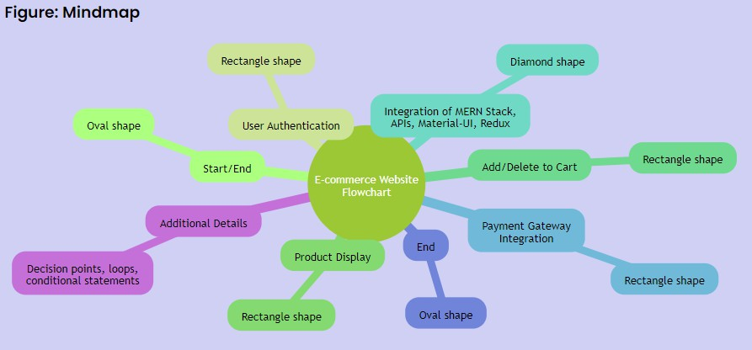

***Figure 2.1 – Flowchart 1***

Creating a flowchart for an e-commerce website project involves visualizing the logical flow of processes and interactions between different components.

* + **Start/End**: Use an oval shape to represent the start and end points of your flowchart.
  + **User Authentication**: Use a rectangle to represent a process. In this case, the process is user authentication.
  + **Product Display:** Another rectangle represents the process of displaying products.
  + **Add/Delete to Cart**: Continue with rectangles for the processes of adding and deleting items from the cart.
  + **MERN Stack, APIs, Material-UI, and Redux:** Represent the integration of MERN stack, APIs, Material-UI, and Redux with a diamond shape, which typically represents a decision or condition. In this case, it represents the integration of these technologies.
  + **Payment Gateway Integration:** Include a rectangle for the process of integrating the payment gateway.
  + **End:** Conclude the flowchart with the end point.

This is a simplified representation, and you can certainly add more details, decision points, and conditions based on the specific functionalities and interactions within your e-commerce website. Use standard flowchart symbols, and connect the shapes with arrows to indicate the flow of processes. Consider including decision points, loops, and conditional statements for a more comprehensive representation of your project's logic.

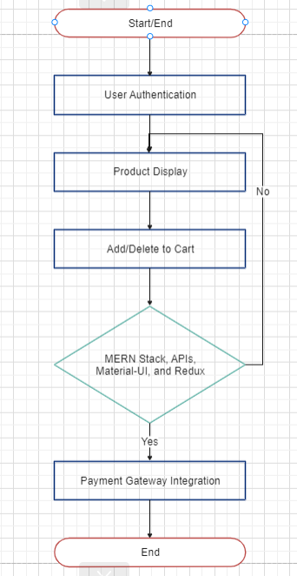

**Figure 2.2 – Flowchart 2**

### ENTITY RELATIONSHIP DIAGRAM

#### Entity Relationship Diagram (ERD) for Umakechoice ecommerce website: Entities:

* Company: This entity represents the ecommerce website, Umakechoice.
* Customer: This entity represents a customer of Umakechoice.
* Product: This entity represents a product that is sold on Umakechoice.
* Order: This entity represents an order that a customer has placed on Umakechoice.
* Shopping Cart: This entity represents a customer's shopping cart on Umakechoice.

#### Relationships:

* Company-Product: A company sells many products.
* Customer-Order: A customer can place many orders.
* Order-Product: An order contains many products.
* Customer-Shopping Cart: A customer has one shopping cart.
* Shopping Cart-Product: A shopping cart contains many products.

#### Attributes:

**Company**:

* Name
* Address
* Phone Number
* Website

#### Customer:

* Name
* Email Address
* Shipping Address
* Billing Address
* Phone Number

#### Product:

* Name
* Description
* Price
* Quantity
* Image

#### Order:

* Order Number
* Customer ID
* Order Date
* Shipping Address
* Billing Address
* Total Price
* Order Status

#### Shopping Cart:

* Customer ID
* Product ID
* Quantity

#### Additional Information:

* The use of MERN stack, APIs, Material-UI, Redux, and an integrated payment gateway is not explicitly represented in the ER diagram, but it is important to note that these technologies would be used to implement the database and the ecommerce website.
* The login and logout feature would be implemented by creating a separate entity called "User" and establishing a relationship between the "Customer" and "User" entities.
* The product displaying feature would be implemented by querying the "Product" entity and displaying the results to the user.
* The add/delete to cart functionality would be implemented by updating the "Shopping Cart" entity.

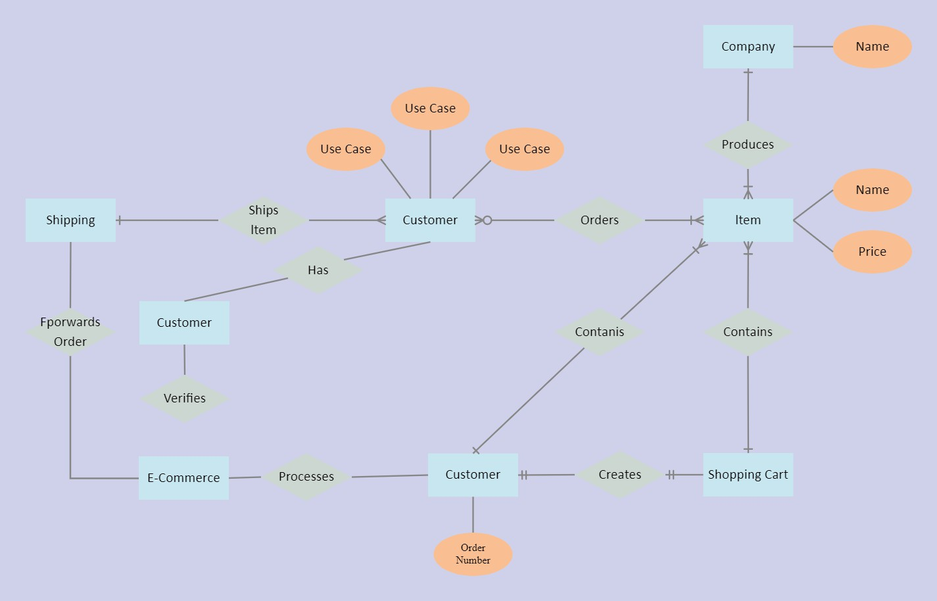

# IMPLEMENTATION

In response to the growing demand for efficient and user-friendly online shopping experiences, our team embarked on the development of 'Umakechoice,' an innovative e- commerce website. This part delves into the technologies and tools utilized in the implementation of the project.

### LANGUAGES / TECHNOLOGIES USED

#### HTML5 (Hypertext Markup Language):

* + Description: HTML5 serves as the standard markup language for structuring documents to be displayed on web browsers. It works in conjunction with Cascading Style Sheets (CSS) and JavaScript, enhancing the presentation and functionality of web pages.
  + Application in 'Umakechoice': HTML5 forms the structural foundation of 'Umakechoice,' defining the layout and elements of the e-commerce website.



#### CSS (Cascading Style Sheets):

* + Description: CSS is a stylesheet language used to control the appearance and formatting of documents written in markup languages. It is applied alongside HTML to modify the visual style of web pages, providing a consistent and visually appealing user interface.
  + Application in 'Umakechoice': CSS is integral to the design of 'Umakechoice,' ensuring a visually pleasing and responsive layout for users.



#### JavaScript:

* + Description: JavaScript is a dynamic programming language commonly used for client-side scripting on web pages. It enables interactions with users, making pages dynamic and responsive. JavaScript works in conjunction with HTML and CSS to create engaging user interfaces.
  + Application in 'Umakechoice': JavaScript enhances the interactivity of 'Umakechoice,' facilitating features like user authentication, cart functionality, and dynamic updates.



#### MERN Stack (MongoDB, Express.js, React, Node.js):

* + **MongoDB (Database):** MongoDB is a NoSQL database that stores data in flexible, JSON-like documents. It is schema-less, allowing for easy and scalable data storage. MongoDB is used to store and manage product data, user information, and other relevant information in 'Umakechoice.'



* + **Express.js (Backend Framework)**: Express.js is a web application framework for Node.js. It simplifies the process of building robust and scalable backend applications. Express.js handles routing, middleware, and server-side logic in 'Umakechoice.'



* + **React (Front-end Library):** React is a JavaScript library for building user interfaces. It allows for the creation of reusable UI components, making the development of interactive and dynamic user interfaces efficient. React is the front-end library used in 'Umakechoice' to create a responsive and engaging user interface.



* + **Node.js (JavaScript Runtime):** Node.js is a JavaScript runtime environment that executes JavaScript code outside of a browser. It enables the development of server-side applications. Node.js is used in 'Umakechoice' to handle server- side logic, API requests, and communication with the database.



#### Material-UI:

* + Description: Material-UI is a React UI framework that implements Google's Material Design principles. It offers a set of pre-designed React components for creating a modern and visually appealing user interface.
  + Application in 'Umakechoice': Material-UI contributes to the aesthetic design of 'Umakechoice,' ensuring a consistent and attractive user interface.



#### Redux:

* + Description: Redux is a state management library for JavaScript applications. It helps manage the state of the application in a predictable way, making it easier to develop and maintain complex applications.
  + Application in 'Umakechoice': Redux is employed in 'Umakechoice' to efficiently manage the state of the application, providing a smooth and responsive user experience.



#### Integrated Payment Gateway:

* + Description: An integrated payment gateway facilitates secure and seamless online transactions. It enables users to make purchases and payments within the e-commerce platform.
  + Application in 'Umakechoice': The integrated payment gateway in 'Umakechoice' ensures a secure and efficient transaction process, providing a trustworthy environment for users.

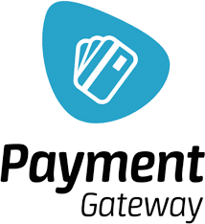

In summary, the technologies and tools utilized in the implementation of 'Umakechoice' collectively contribute to its functionality, user interface, and overall effectiveness as an e- commerce website.

### Proposed Methodology

Our e-commerce platform, 'Umakechoice,' encompasses a seamless process that spans multiple stages to provide users with a comprehensive and user-friendly shopping experience. The workflow of 'Umakechoice' is carefully structured through the following stages:

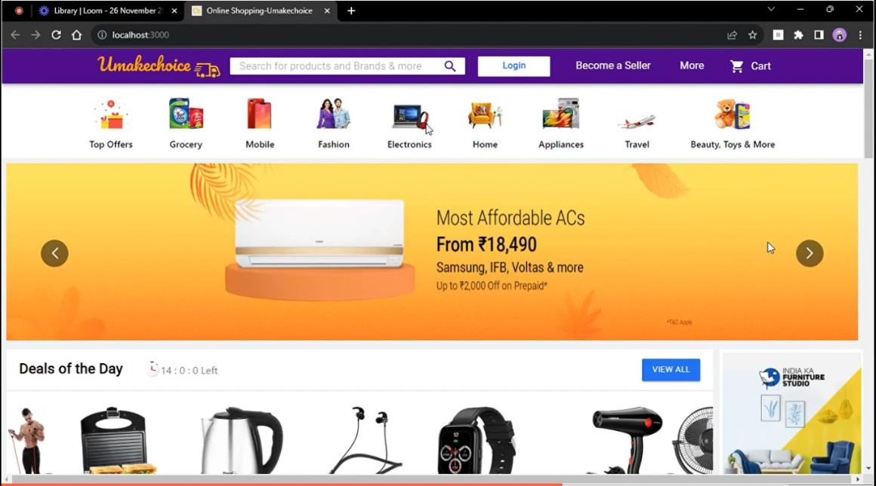

**Figure 3.2.1**

#### Product Exploration:

At the initial stage, users are presented with a diverse range of products to explore on the 'Umakechoice' platform. They can browse through categories, view product details, and identify items of interest.

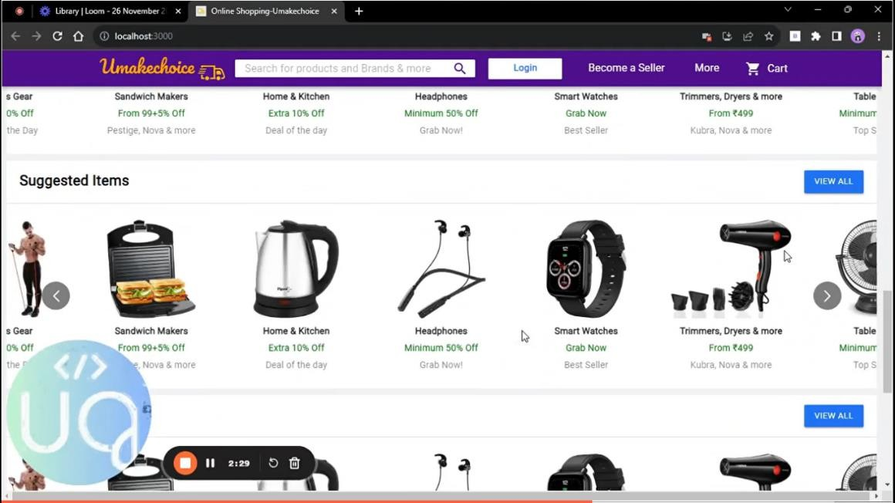

**Figure 3.2.2**

#### User Authentication:

Upon deciding to make a purchase, users move to the user authentication stage. New users are prompted to register on the platform, creating an account for a personalized experience. Registered users can simply log in to proceed further.

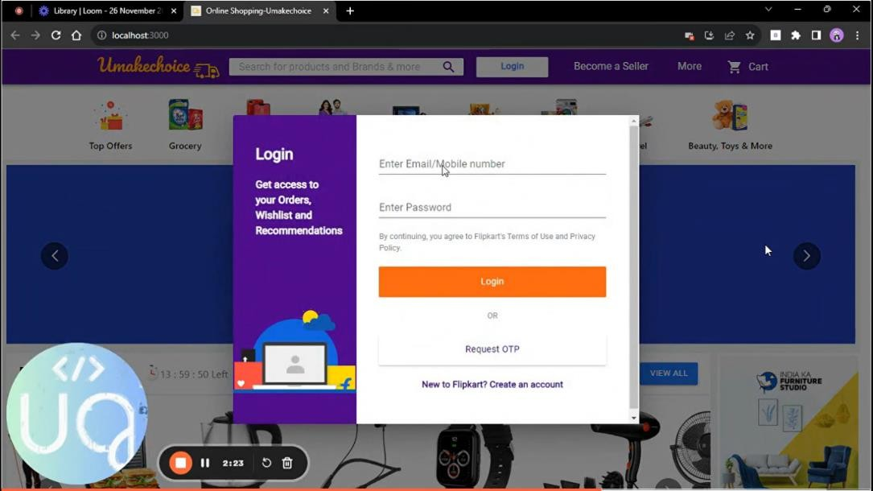

**Figure 3.2.3**

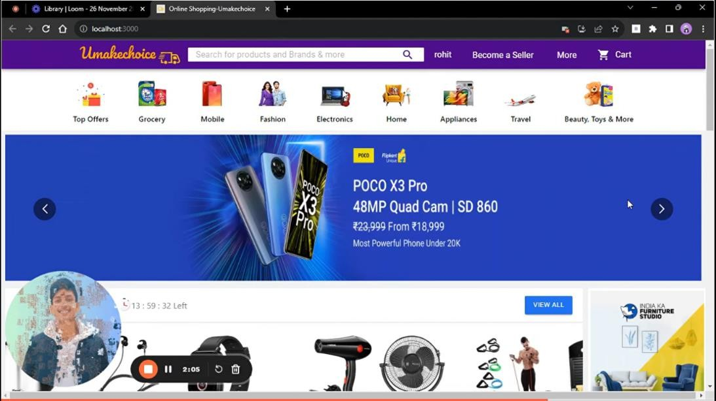

**Figure 3.2.4**

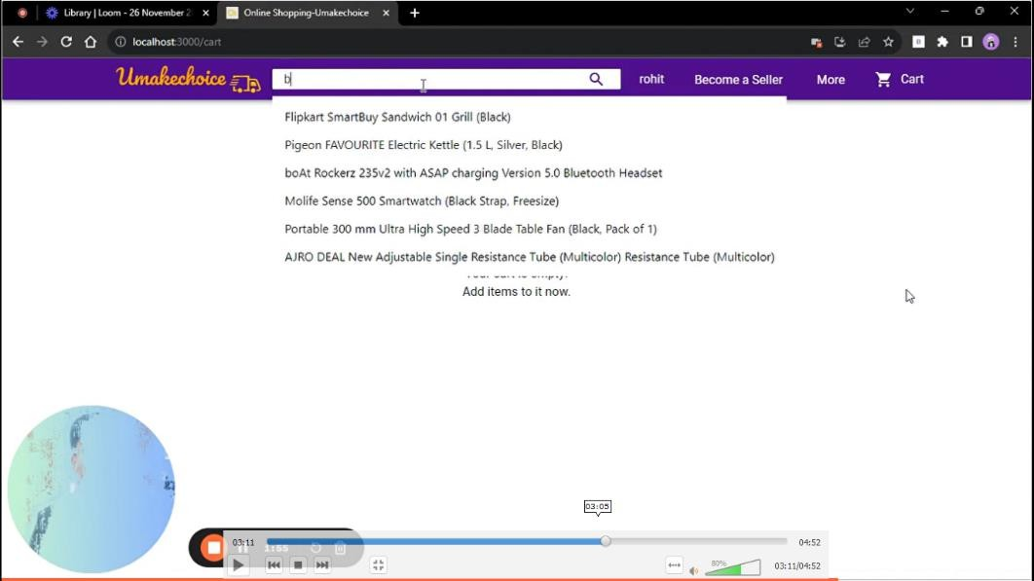

**Figure 3.2.5**

#### Cart Selection and Checkout:

In the third stage, users engage in the process of selecting products and adding them to their shopping cart. 'Umakechoice' offers an intuitive cart management system, allowing users to add or remove items as needed. The checkout process involves providing necessary details and selecting preferred payment methods.

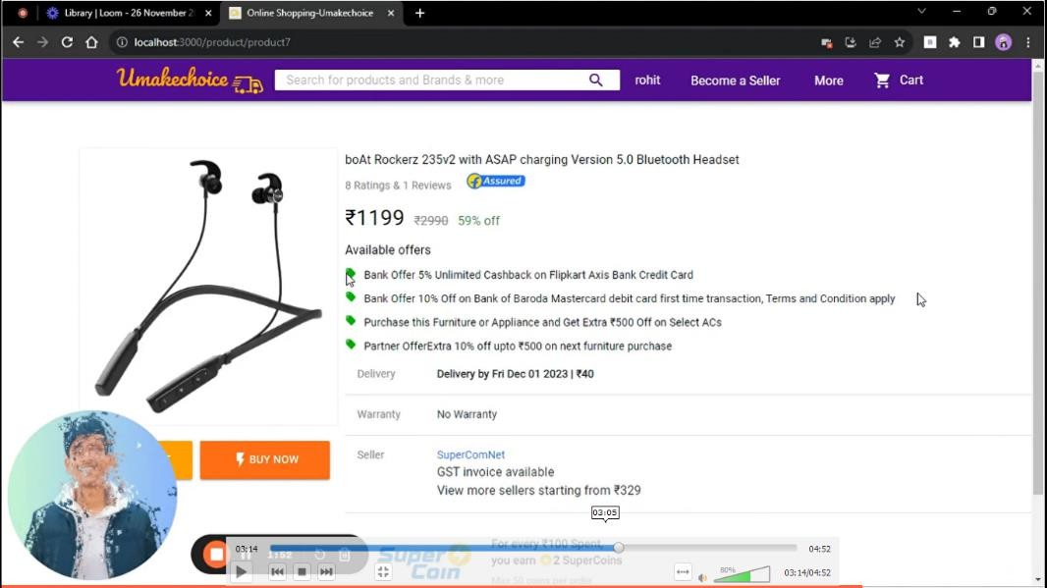

**Figure 3.2.6**

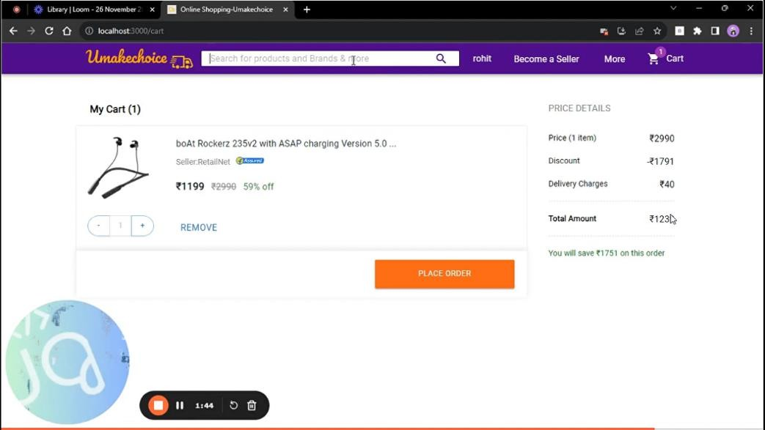

**Figure 3.2.7**

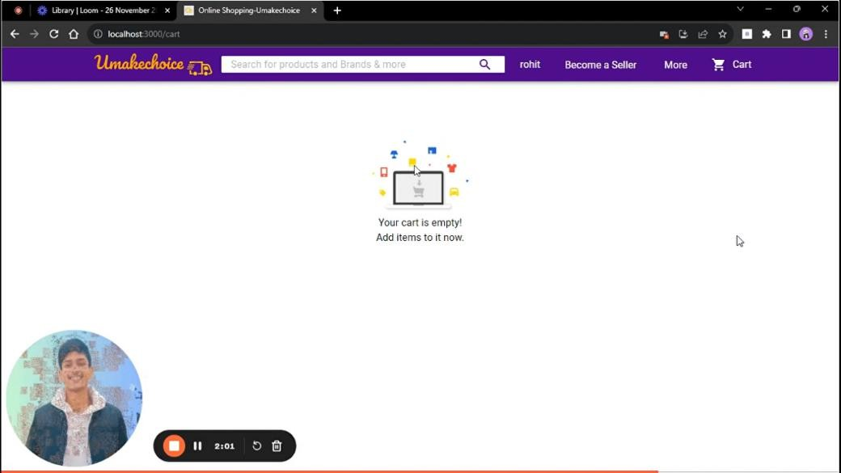

**Figure 3.2.8**

#### Database Integration:

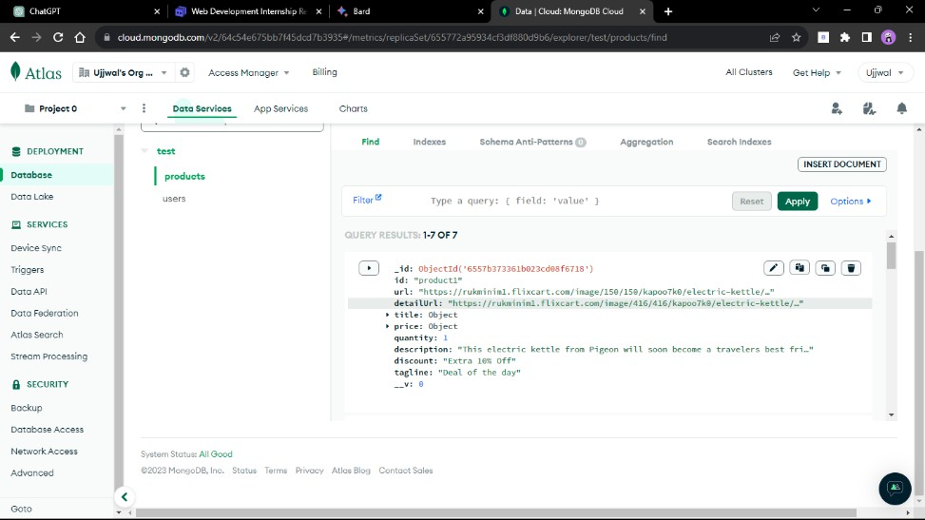Following the completion of the checkout process, user data and order details are seamlessly integrated into our system's database. This stage ensures that the user's purchase information is securely stored for future reference and processing.

**Figure 3.2.9**

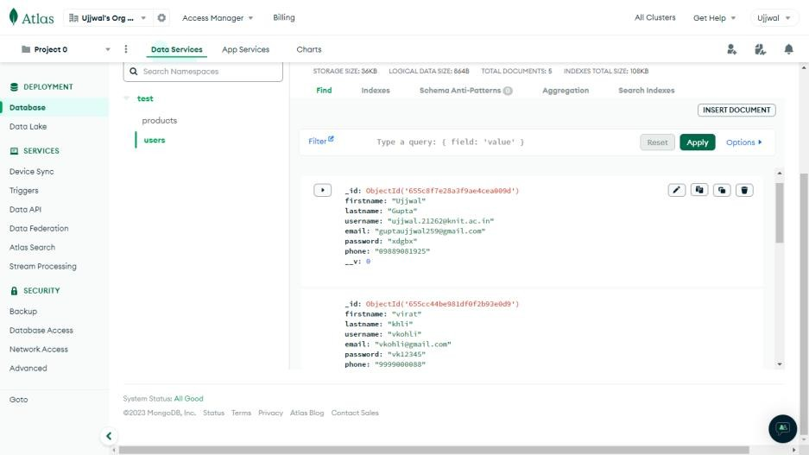

**Figure 3.2.10**

#### Payment Gateway Integration:

One of the critical stages is the integration of a secure payment gateway. 'Umakechoice' incorporates a reliable payment gateway to facilitate secure and efficient transactions. Users can choose from various payment methods, ensuring flexibility and convenience.

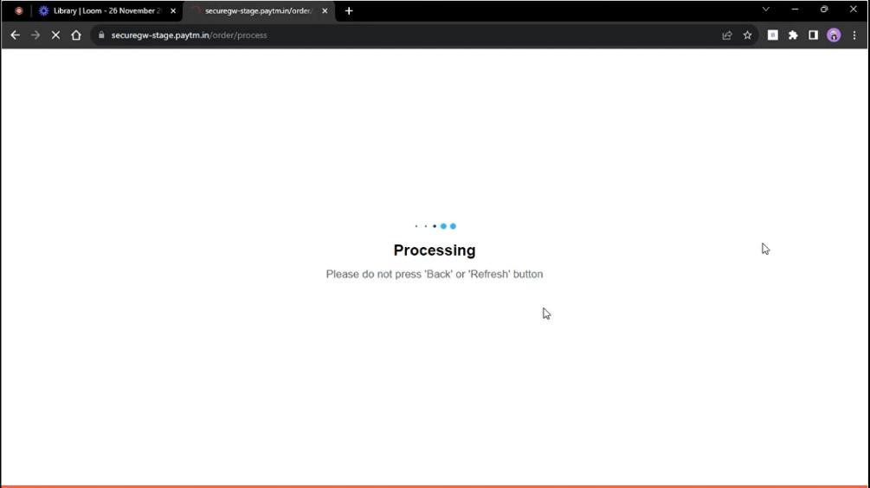

**Figure 3.2.11**

#### Feedback and Review:

While our current version of 'Umakechoice' does not include an explicit feedback process, users are encouraged to provide reviews and feedback through other channels. This valuable input helps us enhance our services and product offerings.

### SUMMARY

This section encapsulates the implementation intricacies of the 'Umakechoice' E-commerce Platform, elucidating its fundamental features encompassing product management, user authentication, and a seamless shopping experience. 'Umakechoice' stands as a dynamic and user-centric online shopping solution, accommodating a diverse array of user needs.

The platform boasts a robust user authentication system, enabling both new users to register and returning users to log in securely. A rich product catalog with intuitive categorization facilitates effortless product exploration, while a sophisticated cart management and checkout system streamlines the purchasing journey. The secure integration of various payment methods ensures flexibility and reliability in transactions.

Built on the MERN stack, 'Umakechoice' prioritizes a responsive design with Material-UI components, ensuring a visually appealing and consistent user interface across devices. Redux enhances state management, contributing to a smooth and responsive user experience. The integration of a secure payment gateway instills confidence in users during the purchasing process.

In conclusion, 'Umakechoice' emerges as a comprehensive e-commerce platform, blending cutting-edge technologies with a user-centric design philosophy. With a commitment to continuous improvement and user feedback, 'Umakechoice' aims to provide a secure, efficient, and enjoyable online shopping environment for users, meeting the diverse needs of the modern online consumer.

## Result and Conclusion

### Conclusion

The 'Umakechoice' e-commerce platform represents a culmination of robust front-end and back-end technologies, resulting in a user-friendly and efficient online shopping experience. Developed in the MERN stack with HTML, CSS, React, and MongoDB, the platform prioritizes simplicity and effectiveness.

The system is designed to be highly intuitive, featuring a menu-driven interface and offering appropriate error messages for user guidance. The front-end tools contribute to the overall user- friendliness, ensuring a seamless navigation experience. With HTML+CSS+React on the front end, the platform caters to modern web development standards, enhancing user engagement.

In the back-end, MongoDB serves as a reliable database, significantly reducing time consumption and simplifying database handling for users. The project stands as a testament to reduced complexity, providing end-users with an array of utilities related to online shopping. The incorporation of combo boxes and text fields streamlines the process, reducing manual efforts for users.

In conclusion, 'Umakechoice' is a fully-fledged and user-friendly e-commerce solution. It not only simplifies the shopping experience for end-users but also offers a comprehensive set of features, making it an ideal choice in the competitive online retail landscape. The project's commitment to reducing complexity, enhancing user convenience, and embracing modern technologies positions 'Umakechoice' as a promising and accessible platform for online shoppers.

### FUTURE SCOPE

#### Enhanced Product Recommendations:

The future scope for 'Umakechoice' includes refining the recommendation engine for products. By implementing machine learning algorithms, the platform can provide more personalized and accurate product recommendations based on user preferences and browsing history.

#### Advanced User Analytics:

Integration with advanced analytics tools can offer insights into user behavior, preferences, and shopping patterns. This data can be leveraged to optimize the platform, tailor marketing strategies, and enhance the overall user experience.

#### Expanded Payment Options:

To cater to a wider audience, the addition of more diverse and region-specific payment options can be considered. This expansion ensures that users from various demographics and locations have convenient and preferred payment methods.

#### Integration with Social Media:

Enhancing the platform's social media integration allows users to share their favorite products, wishlists, or purchases directly on social platforms. This not only boosts user engagement but also serves as a form of organic marketing.

#### Dynamic Inventory Management:

The implementation of dynamic inventory management ensures real-time updates on product availability. This feature prevents situations where users attempt to purchase out-of-stock items, contributing to a more seamless shopping experience.

#### Mobile Application Development:

Considering the increasing use of mobile devices, developing a dedicated mobile application for 'Umakechoice' can enhance accessibility and provide a more tailored experience for users on smartphones and tablets.

#### Customer Feedback and Ratings:

Introducing a comprehensive feedback and rating system allows users to provide reviews on products and their overall shopping experience. This feature not only engages users but also helps in building trust and credibility.

#### Localization for Global Reach:

To expand the platform's reach globally, localization features can be implemented. This includes providing content, product information, and support in multiple languages, ensuring a more inclusive experience for users worldwide.

## Reference

* [https://www.w3schools.com](https://www.w3schools.com/)
* [https://www.stackoverflow.com](https://www.stackoverflow.com/)
* [https://www.wikipedia.com](https://www.wikipedia.com/)
* [https://www.youtube.com](https://www.youtube.com/)
* <https://www.freecodecamp.org/>
* <https://react.dev/>
* <https://nodejs.org/en>
* <https://www.mongodb.com/>

## Appendix

**GitHub**: https://github.com/Coder-Kartikey/WonderLust

**LinkedIn**: [https://www.linkedin.com/in/coderkp/](https://www.linkedin.com/in/ujjwal-gupta-a595811b9/)

**App Link:** https://wonderlust-o9ym.onrender.com